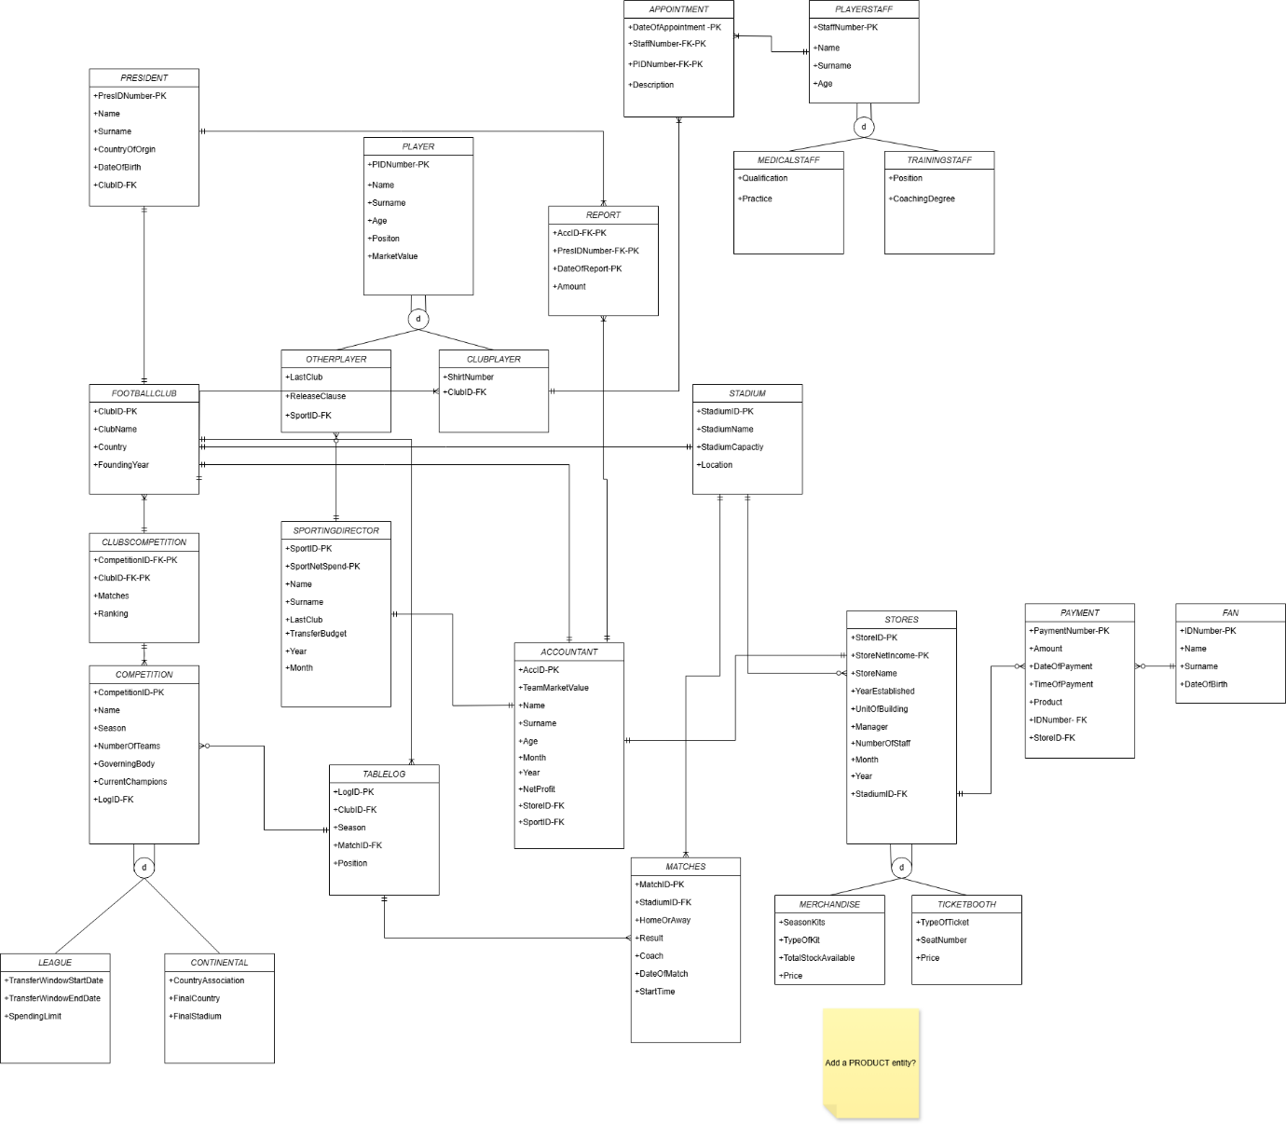
Aveer’s FC Management- Relational Model
PRESIDENT(PresIDNumber, Name,Surname,CountyOfOrgin,DateOfBirth,ClubID)
FOOTBALLCLUB (ClubID, ClubName, Country, FoundingYear)
CLUBSCOMPETITION( CompetitionID, ClubID, Matches, Ranking)
COMPETITION(CompetitionID, Name, Season, NumberOfTeams, GoverningBody, CurrentChampions, LogID)
LEAGUE(CompetitionID, TransferWindowStartDate, TransferWindowEndDate, SpendingLimit)
CONTINENTAL(CompetitionID, CountryAssociation, FinalCountry, FinalStadium)
TABLELOG(LogID, Season, Position, MatchID, ClubID)
MATCHES(MatchID, StadiumID, HomeOrAway, Result, Coach, DateOfMatch, StartTime)
STADIUM(StadiumID, StadiumName, StadiumCapacity, Location)
STORES(StoreID, StoreNetIncome, StoreName, YearEstablished, UnitOfBuilding,Manager, NumberOfStaff, Month, Year, StadiumID)
MERCHANDISE(StoreID, StoreNetIncome, SeasonKits, TypeOfKits, TotalStockAvailable, Price)
TICKETBOOTH(StoreID, StoreNetIncome, TypeOfTicket, SeatNumber, Price)
PAYMENT(PaymentNumber, Amount, DateOfPayment, TimeOfPayment, Product, IDNumber, StoreID)
FAN(IDNumber, Name, Surname, DateOfBirth)
ACCOUNTANT(AccID, TeamMarketValue, Name, Surname, Age, Month, Year, NetProfit, StoreID, SportID)
REPORT(DateOfReport, AccID, PresIDNumber, Amount)
SPORTINGDIRECTOR(SportID, SportNetSpend, Name, Surname, LastClub, TransferBudget, Year, Month)
PLAYER(PIDNumber, Name , Surname, Age ,Position ,MarketValue)
OTHERPLAYER( PIDNumber, LastClub, ReleaseClause, SportID)
CLUBPLAYER(PIDNumber, ShirtNumber, ClubID)
APPOINTMENT(DateOfAppointment, Description , StaffNumber, PIDNumber,)
PLAYERSTAFF(StaffNumber, Name, Surname, Age)
MEDICALSTAFF(StaffNumber, Qualification, Practice)
TRAININGSTAFF(StaffNumber, Position, CoachingDegree)

